Distribution Modelling of Curculigo orchioides in India using MaxEnt

Statistical Ecology: Assignment I
BS in Analytics and Sustainability Studies (2024–28)
Tata Institute of Social Sciences, Mumbai

Under the guidance of Dr. Praveen Kumar
Aarushi Roy
Enrolment No. m2024bsass001
[01-11-2026]

1. Introduction
Curculigo orchioides Gaertn. (Hypoxidaceae), known in India as kali musli or black musli, is a small perennial herb that grows from a tuberous rhizome. The rhizome is a valued drug in Ayurvedic and other traditional systems. Because the plant is collected from the wild rather than cultivated, destructive harvesting together with forest loss has led several authors to describe it as endangered in its natural habitat (Nagesh, 2008; Wala & Jasrai, 2003). It is above ground mainly in the rainy season (Sharma et al., 2008), so it is easily missed in surveys. In the dataset used here, most records come from tropical moist deciduous (196 records), tropical dry deciduous (192) and sal-mixed moist deciduous (136) forest, which points to a herb of the deciduous forest floor.
Species distribution models (SDMs) relate known occurrences to environmental conditions and project that relationship across a landscape to estimate where suitable habitat exists. MaxEnt is a presence–background method widely used when reliable absence data are lacking (Phillips et al., 2006; Elith et al., 2011). This report models the habitat suitability of C. orchioides across India using WorldClim bioclimatic variables, slope and Sentinel-2 NDVI. It aims to (i) prepare and check the occurrence and environmental data, (ii) identify which variables shape the predicted distribution and what ecological processes they represent, and (iii) evaluate the model and discuss its use for conservation planning, climate-change studies and invasion-risk work.

2. Data and Methods

2.1 Occurrence data and cleaning
The course occurrence file contained 985 records of C. orchioides with coordinates, forest type, and the number of individuals counted from the provided dataset. All processing was done in R with the terra, geodata and corrplot packages. Table 1 lists each cleaning step and the remaining records, and Figure 1 maps all records.
Table 1. Occurrence-data cleaning steps and records remaining.
Step | Action | Records
1 | Raw records in course dataset | 985
2 | Removed exact duplicate coordinates (18 records) | 967
3 | Checked for missing or impossible coordinates and for points outside India (GADM 4.1 boundary) | 967 (0 removed)
4 | Removed records outside the study window of 72–90°E, 10.5–34°N (14 Tamil Nadu, 8 Kerala, 2 Gujarat) | 943
5 | Removed records with no value in one or more layers (4 on the Kerala edge of the window, 4 on the Odisha coast) | 935
6 | Spatial thinning: kept one record per 30-arc-second (~1 km) cell | 910
7 | MaxEnt random split: 75% training / 25% test | 683 / 227
Source: Author's analysis of the course occurrence dataset; boundaries from GADM (2022).
Several further checks were made for spatial errors. The state code in each record ID was compared with the state in which its coordinates fall. Of 76 mismatches, 60 were records coded as Andhra Pradesh that lie in present-day Telangana, and two were coded as Uttarakhand but lie in Uttar Pradesh. These are most likely labels from before the states were reorganised rather than coordinate errors; the rest lie close to state borders. In addition, 13 records had coordinates rounded to the nearest arc-minute (about 1.8 km), which is coarser than the 1 km grid. They were kept but add positional uncertainty. Another 13 records were labelled with the wrong family (Oxalidaceae rather than Hypoxidaceae); all came from a single site in Gujarat, and 12 of them were duplicates.
The 910 modelling records span 18 states but are concentrated in eastern India: Odisha (305), Chhattisgarh (129), Jharkhand (88), and Karnataka (88), which together hold 67% of them. An all-India extent was chosen because the species is recorded across the country, so a national extent captures more of its environmental range than any single region. The extent was limited to 72–90°E and 10.5–34°N, the coverage of the available NDVI composite, so southern Kerala and Tamil Nadu, the North-East and the far west lie outside the model.
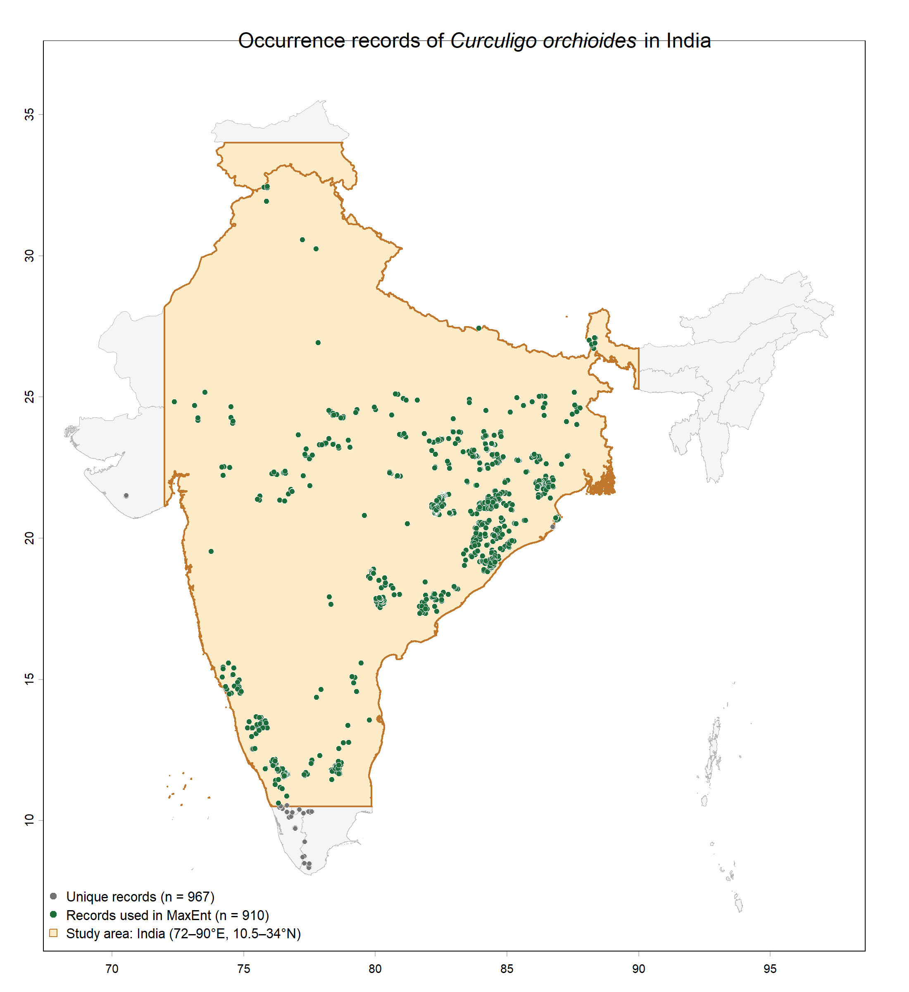
Figure 1. Unique occurrence records of C. orchioides (grey, n = 967) and records used in MaxEnt (green, n = 910), with the study window shaded. Source: course occurrence dataset; boundaries from GADM (2022); author's map in R.

2.2 Environmental layers and variable selection
A total of 22 candidate predictors were put together (Table 2). The 19 bioclimatic variables (BIO1–BIO19) are from WorldClim 2.1 at a 30-arc-second (~1 km) scale and give the 1970–2000 averages (Fick & Hijmans, 2017). Elevation is taken from the 30-arc-second layer of WorldClim 2.1, sourced from SRTM data (Farr et al., 2007), and the slope in degrees is computed from it via terra::terrain. For NDVI, we have a Sentinel-2 mean composite made in Google Earth Engine (Drusch et al., 2012; Gorelick et al., 2017) which was exported at roughly 1 km and bilinearly resampled to the WorldClim grid. After all layers were cropped to the study window and masked for the GADM India boundary, the resulting stack has a common projection (WGS 84, EPSG:4326), extent (72–90°E, 10.5–34°N; 2,160 × 2,820 cells) and resolution (0.00833°, ~0.9 km). MaxEnt’s header check verified the grids were in order (Figure 2).

Table 2. Candidate environmental variables, with values across the study area (✓ = retained in the final model).
Code | Variable | Unit | Min | Max | Mean | Used
bio1 | Annual mean temperature | °C | −19.46 | 29.58 | 24.51
bio2 | Mean diurnal range | °C | 4.97 | 16.36 | 12.06 | ✓
bio3 | Isothermality (bio2/bio7 × 100) | % | 26.44 | 67.13 | 44.35
bio4 | Temperature seasonality (SD × 100) | °C × 100 | 69.68 | 1073.77 | 477.62 | ✓
bio5 | Max temperature of warmest month | °C | −7.80 | 44.20 | 38.06
bio6 | Min temperature of coldest month | °C | −33.40 | 23.60 | 10.27
bio7 | Temperature annual range | °C | 7.80 | 40.70 | 27.79
bio8 | Mean temperature of wettest quarter | °C | −16.73 | 34.42 | 26.36
bio9 | Mean temperature of driest quarter | °C | −23.37 | 31.42 | 22.16 | ✓
bio10 | Mean temperature of warmest quarter | °C | −11.80 | 35.00 | 30.17
bio11 | Mean temperature of coldest quarter | °C | −26.75 | 26.88 | 18.28
bio12 | Annual precipitation | mm | 67 | 7663 | 1073.17
bio13 | Precipitation of wettest month | mm | 14 | 2982 | 313.76 | ✓
bio14 | Precipitation of driest month | mm | 0 | 39 | 3.64 | ✓
bio15 | Precipitation seasonality (CV) | % | 30.72 | 175.05 | 121.42 | ✓
bio16 | Precipitation of wettest quarter | mm | 34 | 6637 | 763.83
bio17 | Precipitation of driest quarter | mm | 0 | 195 | 22.88
bio18 | Precipitation of warmest quarter | mm | 25 | 3120 | 223.84 | ✓
bio19 | Precipitation of coldest quarter | mm | 0 | 5645 | 74.88 | ✓
elev | Elevation (WorldClim 2.1, SRTM-derived) | m | −47 | 8081 | 524.12
slope | Slope (derived from elevation) | degrees | 0 | 49.98 | 1.60 | ✓
ndvi | Normalised Difference Vegetation Index (Sentinel-2) | – | −0.59 | 0.84 | 0.41 | ✓
Source: WorldClim 2.1 (Fick & Hijmans, 2017); SRTM via WorldClim (Farr et al., 2007); Sentinel-2 via Google Earth Engine (Drusch et al., 2012; Gorelick et al., 2017). Summary values computed by the author.
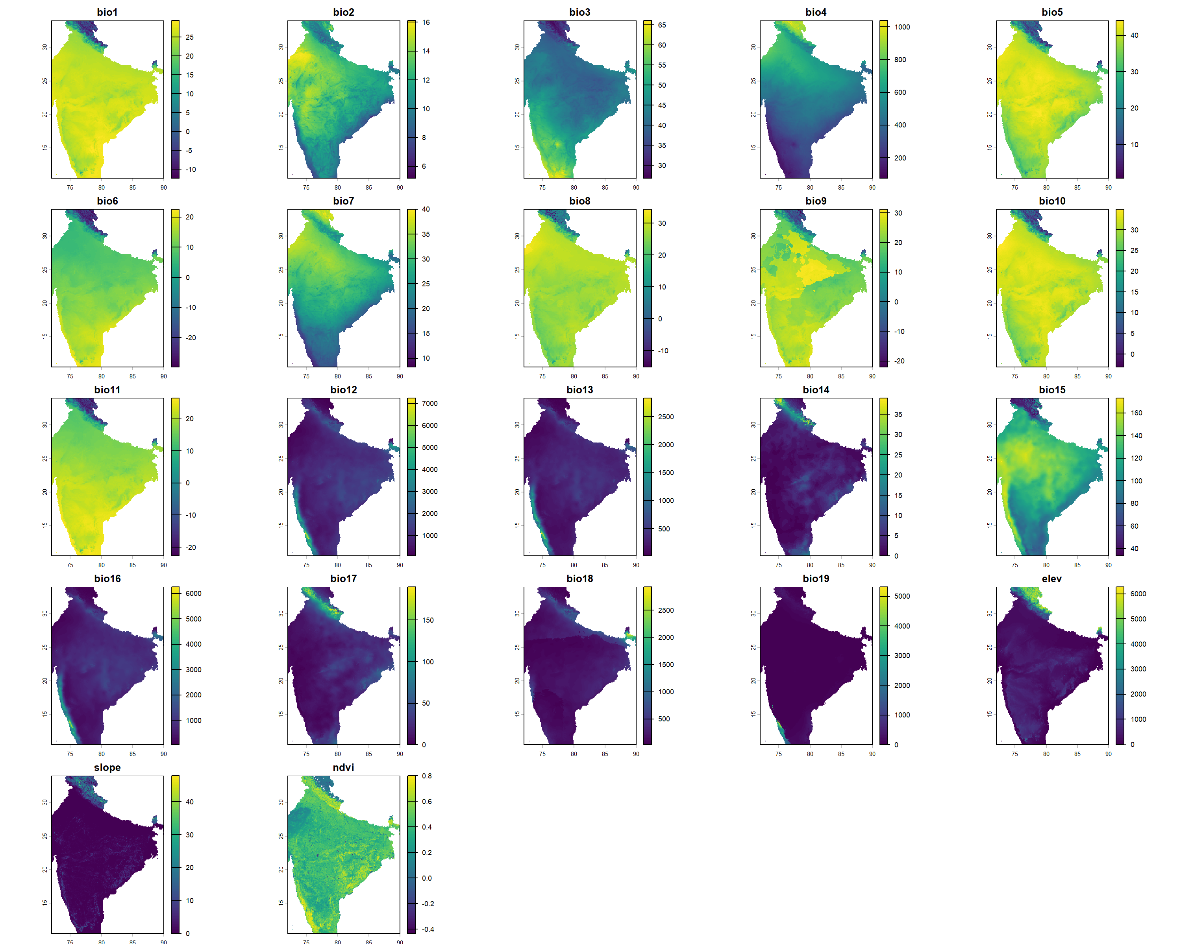
Figure 2. The 22 candidate layers clipped to the study area (common grid: WGS 84, 30 arc-seconds). Source: as for Table 2; author's maps in R.
Correlation among the 22 layers was assessed using Pearson's r across 10,000 randomly selected cells (Figure 3). Twenty-six pairs had |r| > 0.8, for example, bio13 and bio16 (0.99), bio5 and bio10 (0.98) and bio1 and elevation (−0.97). Strongly correlated predictors make variable importance and response curves unstable (Dormann et al., 2013), so a subset was selected. NDVI and slope were placed first in the ranking to retain both the vegetation and the topographic layers. The remaining variables were ordered by their permutation importance in a preliminary all-variable MaxEnt run made during exploratory analysis of the Odisha–Chhattisgarh records. Moving down this list, a variable was kept only if its |r| was below 0.7, with all variables already kept. This left ten predictors (Table 2), with a maximum pairwise |r| of 0.65 (Figure 4). Elevation was excluded because it is correlated with slope (r = 0.74), which already represents topography.
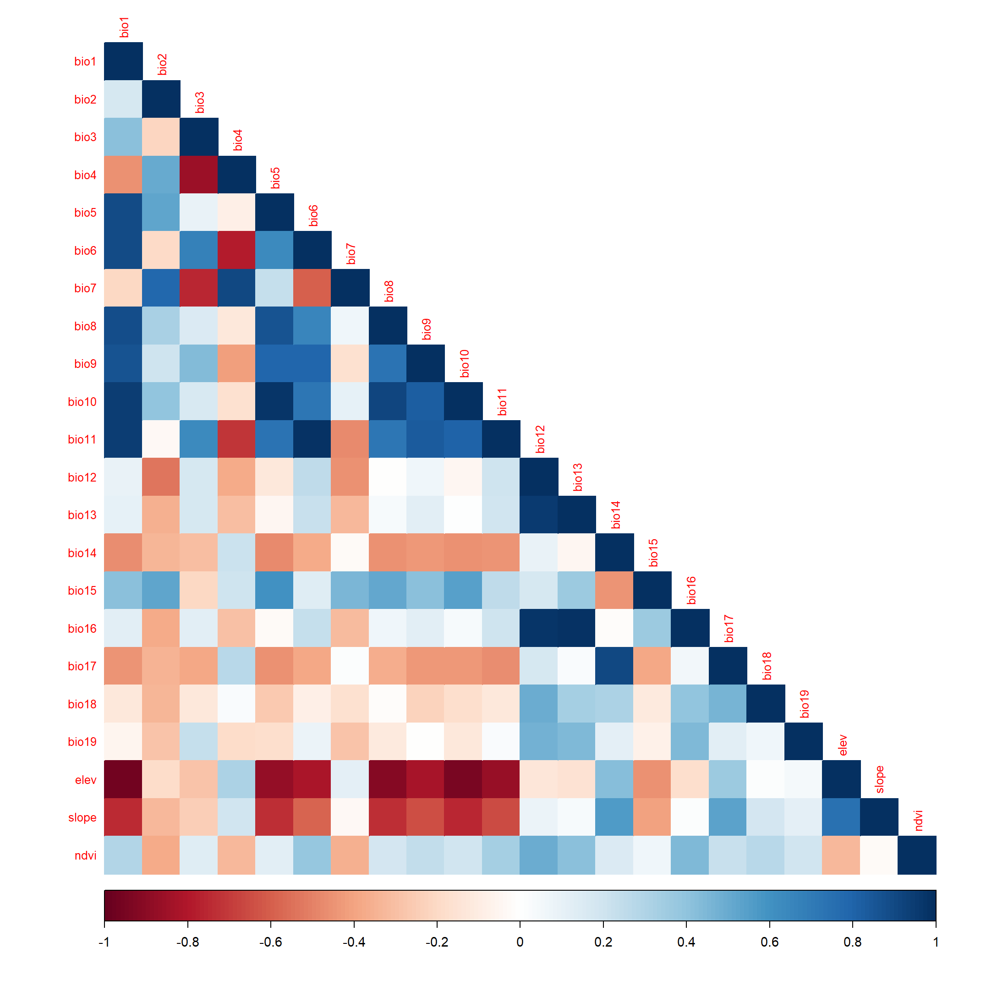
Figure 3. Pearson correlation matrix of the 22 candidate predictors across 10,000 random cells. Source: author's analysis in R (corrplot).
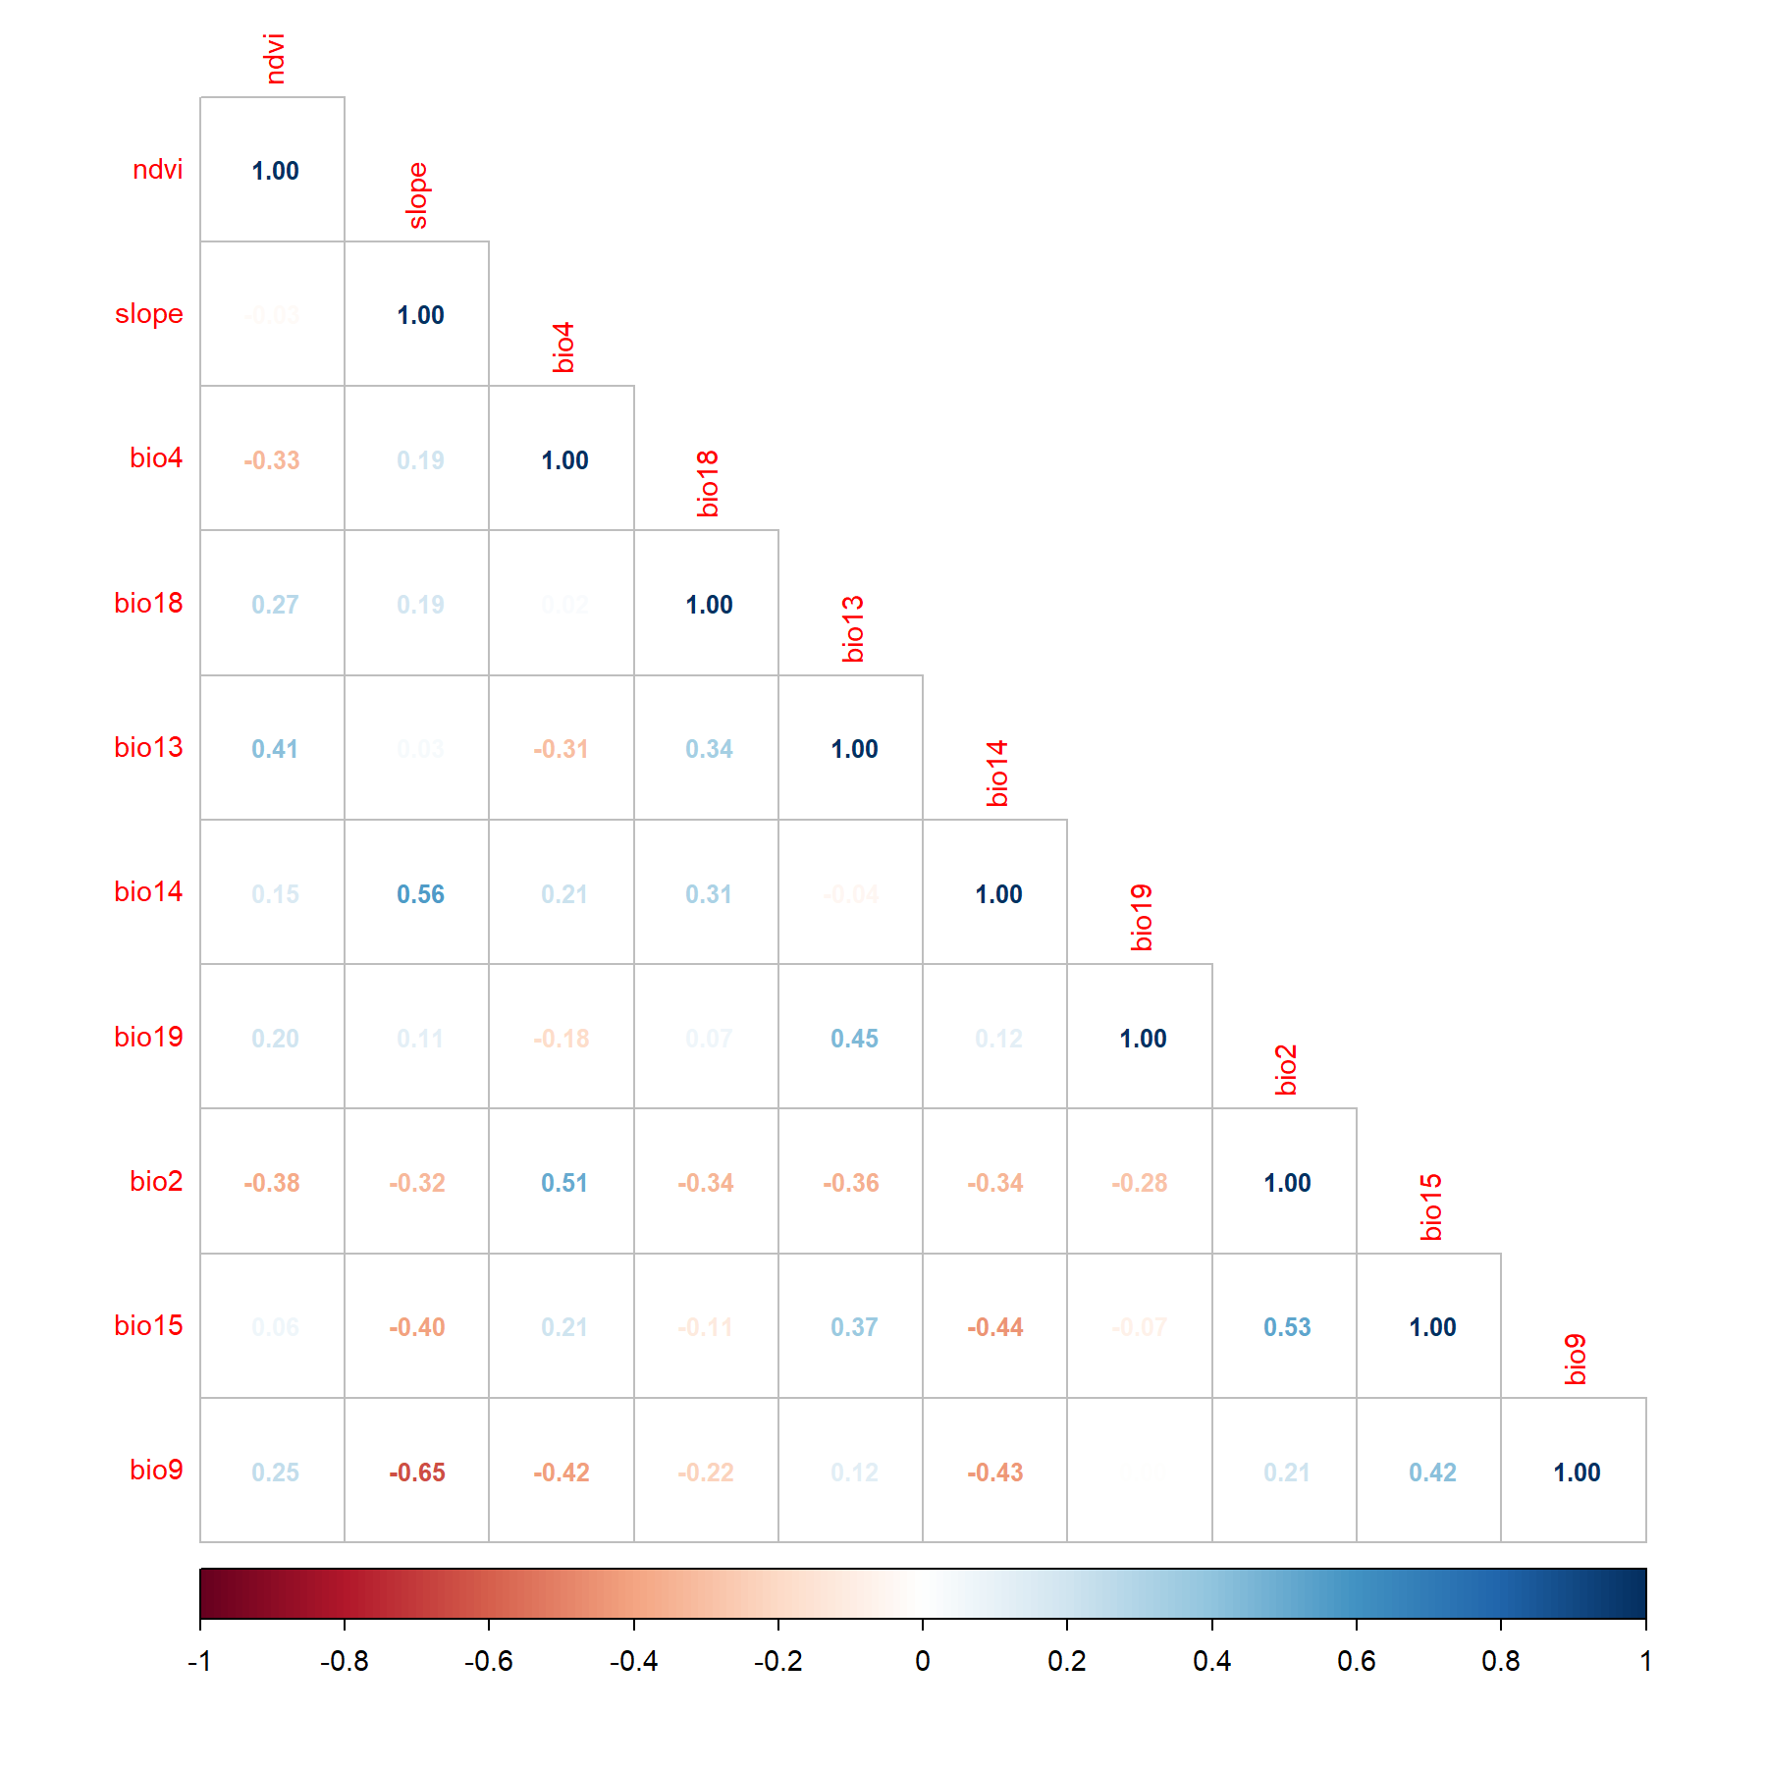
Figure 4. Correlations among the ten retained predictors (maximum |r| = 0.65). Source: author's analysis in R (corrplot).

2.3 MaxEnt modelling
The model was fitted in MaxEnt 3.4.4 (Phillips et al., 2006, 2017) using the settings in Table 3. A random 25% of records were held back for testing, and response curves, jackknife tests and logistic output were requested.
Table 3. MaxEnt settings.
Setting | Value
Software | MaxEnt 3.4.4
Predictors | 10 continuous layers: ndvi, slope, bio2, bio4, bio9, bio13, bio14, bio15, bio18, bio19
Presence records | 910 (683 training, 227 test; random 25% test, random seed)
Background | 10,000 random points + presences (10,680 points in total)
Feature classes (auto) | Linear, quadratic, product, hinge
Regularisation | Multiplier 1 (β: linear/quadratic/product 0.05, hinge 0.5)
Maximum iterations | 500 (default; the limit was reached)
Output format | Logistic
Replicates | 1
Source: MaxEnt output HTML and run log (author's run, 1 November 2026).

3. Results

3.1 Model performance
The model achieved a training AUC of 0.901 and a test AUC of 0.883 (SD 0.008; DeLong et al., 1988). The regularised training gain was 1.170, the unregularised training gain was 1.283, and the test gain was 1.121 (Table 4). The ROC curves for training and test data lie close together and well above the line for a random model (Figure 5). Binomial tests showed that test points were predicted significantly better than random at every standard threshold (all p < 10⁻¹⁰).
Table 4. Model performance metrics.
Metric | Training | Test
AUC | 0.901 | 0.883 (SD 0.008)
Gain | 1.170 (regularised); 1.283 (unregularised) | 1.121
Omission at 10th-percentile training presence (logistic 0.256) | 0.100 | 0.150
Omission at maximum training sensitivity + specificity (logistic 0.230) | 0.076 | 0.119
Omission at minimum training presence (logistic 0.003) | 0.000 | 0.000
Source: MaxEnt output (maxentResults.csv).
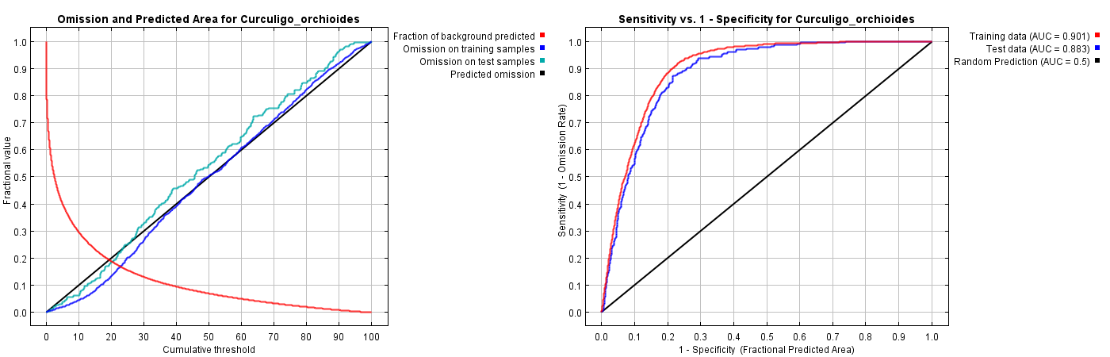
Figure 5. Omission and predicted area against cumulative threshold (left) and ROC curve for training and test data (right). Source: MaxEnt output.

3.2 Predicted habitat suitability
High suitability forms one large core in eastern and central India, covering the Odisha–Chhattisgarh–Jharkhand plateau, the northern Eastern Ghats of Andhra Pradesh and parts of eastern Madhya Pradesh (Figure 6). Smaller zones run along the Western Ghats and their foothills in Karnataka and Kerala, as a narrow band along the Himalayan foothills of Uttarakhand and Himachal Pradesh, and in pockets of north Bengal and Sikkim. Suitability is low across the Indo-Gangetic plain, the arid north-west, most of the interior Deccan plateau and the high Himalaya.
At the 10th-percentile training-presence threshold (logistic 0.256), about 435,900 km² (16.8% of the 2.6 million km² modelled area) is classed as suitable (Figure 7). Only about 167,200 km² (6.4%) has suitability of 0.5 or more. Odisha and Chhattisgarh together hold 37% of the suitable area, and more than half of each state is classed as suitable (Table 5).
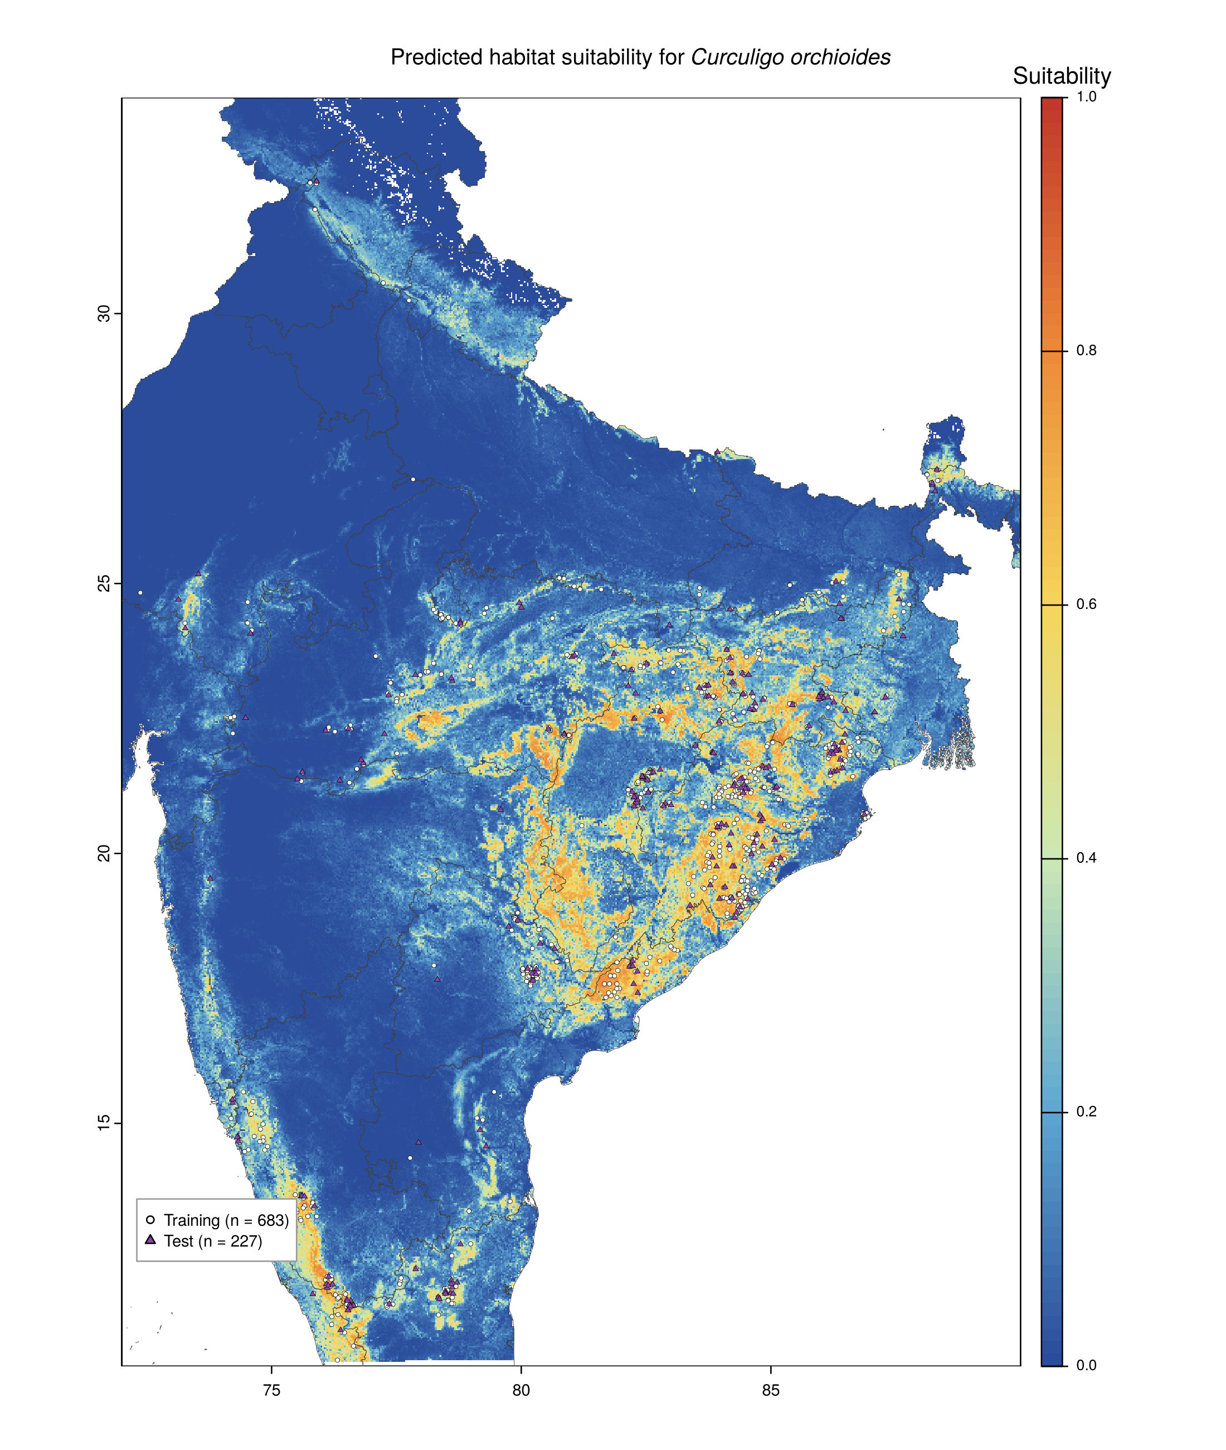
Figure 6. Predicted habitat suitability (MaxEnt logistic output) with training (white circles) and test (purple triangles) records. Source: MaxEnt output grid, mapped by the author in R.
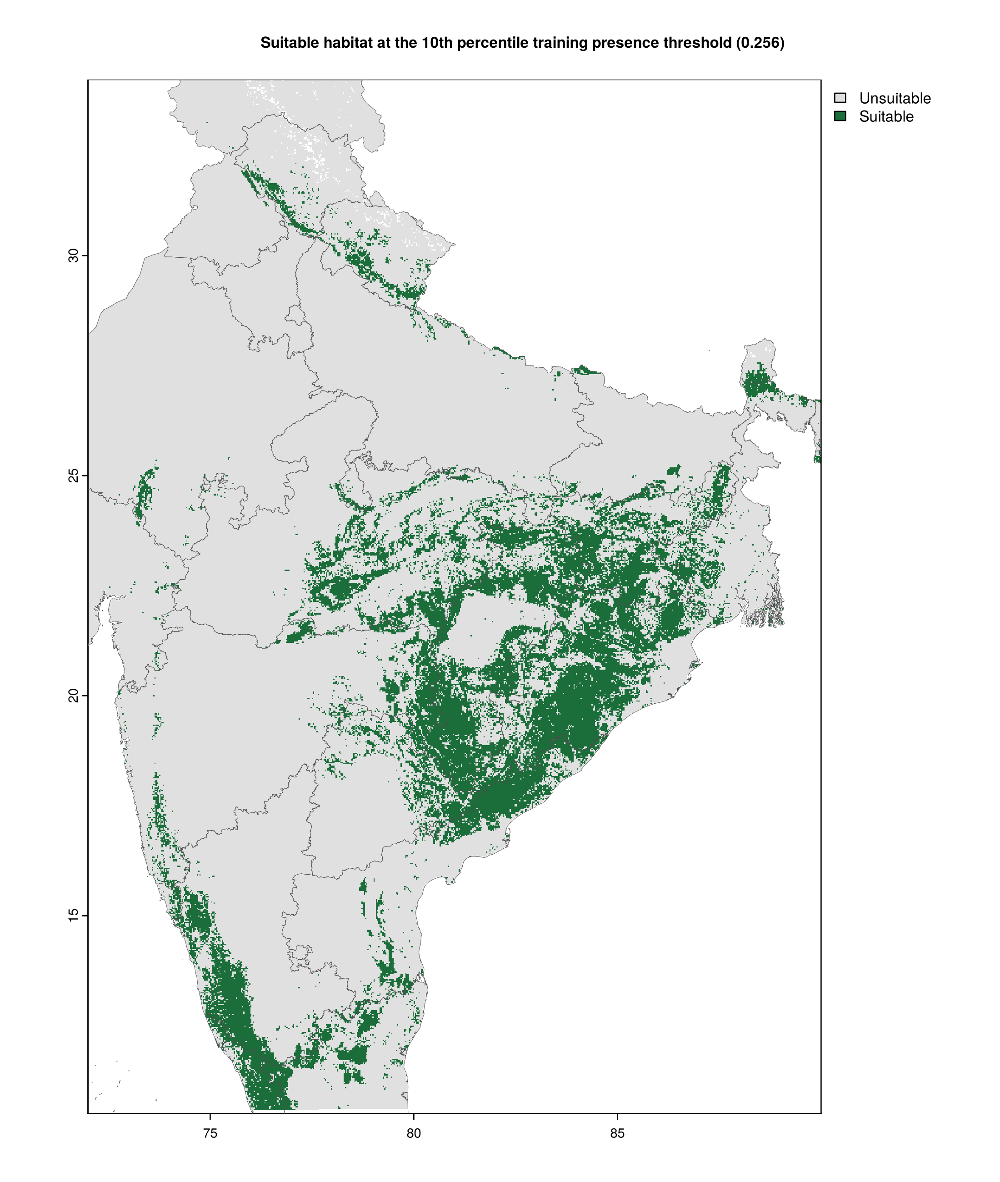
Figure 7. Suitable and unsuitable habitat at the 10th-percentile training-presence threshold (0.256). Source: author's classification of the MaxEnt output.
Table 5. States with the largest suitable area (threshold 0.256).
State | Suitable area (km²) | % of state modelled | % of all suitable area
Odisha | 90,623 | 58.5 | 20.8
Chhattisgarh | 71,783 | 53.0 | 16.5
Madhya Pradesh | 48,079 | 15.6 | 11.0
Jharkhand | 38,238 | 47.8 | 8.8
Andhra Pradesh | 34,666 | 21.8 | 8.0
Karnataka | 32,391 | 17.0 | 7.4
Maharashtra | 28,767 | 9.4 | 6.6
Telangana | 18,702 | 16.3 | 4.3
Source: Author's calculation from the MaxEnt output and GADM (2022) state boundaries.

3.3 Variable contributions and jackknife
NDVI is the most important variable across all measures (Table 6). It has the highest percent contribution (37.0%), permutation importance (35.5%) and single-variable gain (0.765), and leaving it out causes the largest drop in training gain (1.170 to 1.039) (Figures 8 and 9). Slope ranks second, with a 21.7% contribution and a single-variable AUC (0.794) almost as high as NDVI's. On the test data, omitting slope reduces test gain and test AUC more than omitting any other variable, including NDVI (test AUC 0.869). Slope therefore carries information that no other variable provides. Of the climate variables, the most important ones are mean diurnal range (bio2, 16.9% permutation importance), wettest-month rainfall (bio13, 13.2% contribution), temperature seasonality (bio4) and driest-quarter temperature (bio9).
Table 6. Variable contributions and single-variable jackknife results.
Variable | % contribution | Permutation importance | Training gain alone | Test AUC alone
ndvi | 37.0 | 35.5 | 0.765 | 0.804
slope | 21.7 | 10.4 | 0.465 | 0.794
bio13 | 13.2 | 12.8 | 0.345 | 0.707
bio2 | 8.0 | 16.9 | 0.452 | 0.750
bio14 | 6.7 | 1.6 | 0.194 | 0.666
bio4 | 5.5 | 8.0 | 0.294 | 0.713
bio9 | 3.0 | 7.7 | 0.252 | 0.691
bio19 | 2.1 | 1.7 | 0.118 | 0.620
bio18 | 1.7 | 2.6 | 0.321 | 0.710
bio15 | 1.1 | 2.8 | 0.094 | 0.606
Source: MaxEnt output (maxentResults.csv).
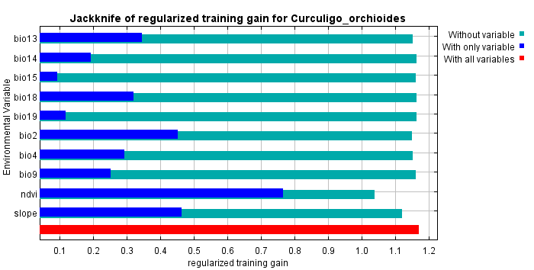
Figure 8. Jackknife of regularised training gain. Source: MaxEnt output.
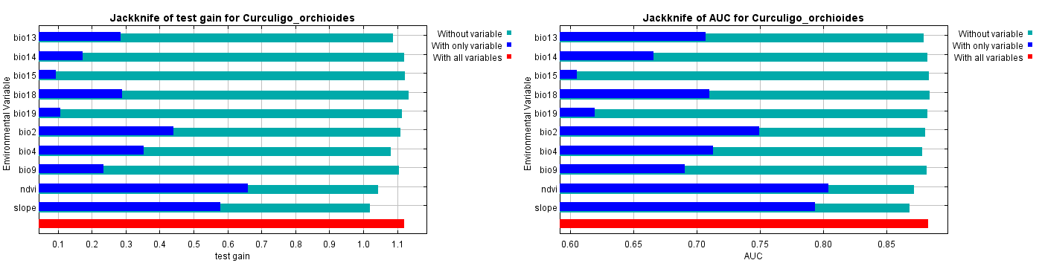
Figure 9. Jackknife of test gain (left) and test AUC (right). Source: MaxEnt output.

3.4 Response curves
The marginal response curves (Figure 10) show how suitability changes as one variable is varied while the others are held at their average values. Suitability is near zero at NDVI below 0.1, rises steeply between 0.3 and 0.75, and levels off slightly lower above 0.8. Presence sites averaged NDVI 0.58, compared with 0.41 across the study area. Perfectly flat ground has low suitability, which jumps to about 0.70 once the slope exceeds about 1°, remains high up to about 12°, and declines on steeper slopes. Suitability is high where the mean diurnal temperature range (bio2) is below about 12 °C and approaches zero above 15 °C. It peaks at about 430 mm of rainfall in the wettest month (bio13) and declines steadily in very wet areas. It peaks at a moderate temperature seasonality (bio4 ≈ 480) and falls in the strongly seasonal north-west. It is near zero where the driest quarter is below 0 °C (bio9) and high above about 17 °C. The single-variable models confirm the NDVI and slope patterns (Figure 11). Several curves, notably bio9, bio18, bio19 and bio15, contain abrupt spikes or V-shapes that are hard to explain ecologically; these are discussed under overfitting.
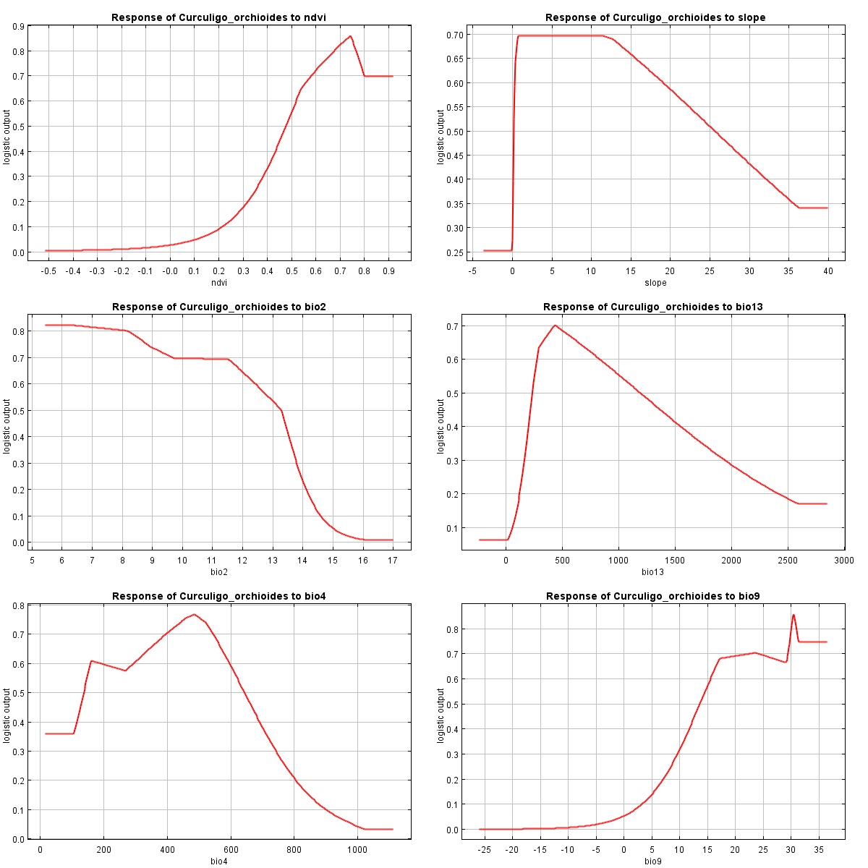
Figure 10. Marginal response curves for the six most influential variables (left to right, top to bottom: ndvi, slope, bio2, bio13, bio4, bio9). Curves for the other four variables are in the submitted MaxEnt output. Source: MaxEnt output.
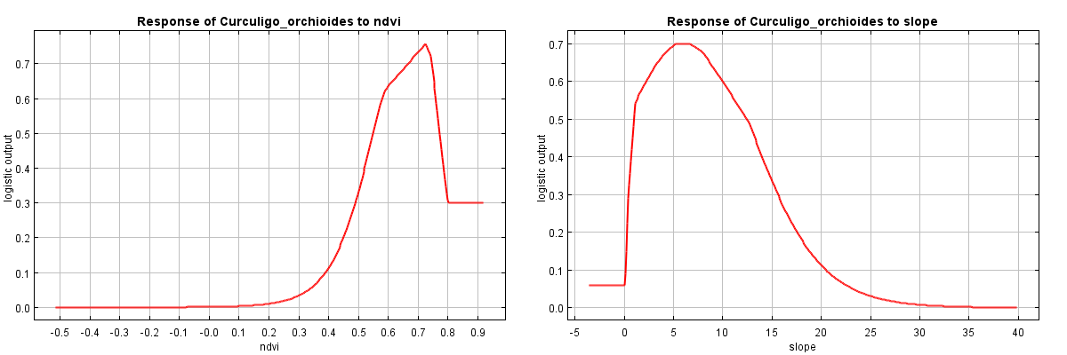
Figure 11. Response curves from single-variable models for NDVI (left) and slope (right). Source: MaxEnt output.

4. Discussion

4.1 Which variables matter and what they represent
Pettorelli et al. (2005) use NDVI to measure the quantity of green, photosynthetically active vegetation in a pixel. Across India, the one thing that most clearly sets C. orchioides sites apart from the background is the extent of dense vegetation. It is a forest-floor herb one would expect to find in a deciduous forest, and, as Wala & Jasrai (2003) note, it has been declining due to forest clearing and the loss of litter cover. The NDVI provides a present-day view of the habitat and is not merely an indication of climatic potential.
Slope stands for terrain. Gently to moderately sloping land on plateaus, hills and foothills is where forest remains in much of India, because flat land has largely been converted to agriculture. Such land also drains well, which suits a plant with a fleshy rhizome. The drop in suitability on steep slopes probably reflects thin soils and the high Himalaya. The climate variables mostly describe the monsoon regime and continentality. The peak in wettest-month rainfall at moderate values matches a plant that grows during the monsoon (Sharma et al., 2008) but does not appear to favour the very wettest parts of the Western Ghats and the North-East. The negative effect of large diurnal ranges and strong seasonality reflects the exclusion of the hot, arid and continental north-west. The low suitability where the dry season is cold (bio9) explains the exclusion of high altitudes.

4.2 Interpreting AUC: strengths and weaknesses
With an AUC of 0.883, a random test presence is more likely to be given a higher suitability than a random background point 88% of the time. On the commonly used scale, this is a "good" model (Swets, 1988). In presence–background models the maximum AUC that can be achieved is below 1, because the background also contains good sites (Phillips et al., 2006).
The AUC is useful because it does not require a threshold and summarises the whole ROC curve in a single number. It is also easy to compare between models of the same species and area. Its weaknesses are well documented (Lobo et al., 2008):
- AUC depends on the study extent. An all-India background includes large, obviously unsuitable areas such as the Thar Desert and the high Himalaya, which inflates AUC, so the value cannot be compared with studies at other extents.
- With presence–background data, it measures how well presences are separated from the background, not from true absences.
- It ignores the actual predicted values and treats omission and commission errors as equally costly.
- When test records are drawn at random from clustered data, many lie close to training records, so test AUC partly reflects spatial autocorrelation

4.3 Signs of overfitting
The train–test AUC gap is small (0.901 vs. 0.883), suggesting limited overfitting. Other evidence points to moderate overfitting. Test omission at the 10th-percentile threshold is 0.150, compared with the expected 0.10. The unregularised training gain (1.283) is clearly higher than the test gain (1.121) (Radosavljevic & Anderson, 2014). Several response curves (bio9, bio18, bio19 and bio15) also show sharp spikes typical of hinge and product features fitting noise (Merow et al., 2013). Because the test set was obtained via a random split of clustered records, the true degree of overfitting is likely greater than these statistics suggest. Spatially blocked cross-validation and tuning of the regularisation multiplier would give a more honest estimate. Reducing the number of predictors from 22 to 10 uncorrelated variables already limits a major source of overfitting.

4.4 What the predicted distribution tells us
The model suggests that the appropriate habitat for C. orchioides occupies only approximately one-sixth of the modelled area. It is found primarily in the forested plateaus and hills of eastern and central India and, secondarily, in the Western Ghats and Himalayan foothills. This corresponds to the known association with deciduous forests, as well as to the location where the plant has been recorded. However, it does not indicate its presence or the pressure from harvesting, grazing, or dispersal. Second, there is an over-concentration of records in Odisha and Chhattisgarh, with 48% of modelling records in these two states. These states have a very high suitability prediction, which may be partly due to sampling effort, but sparsely surveyed states like Maharashtra may be underpredicted (Kramer-Schadt et al., 2013).

4.5 Applications
Conservation planning. The suitability and binary maps can be used to direct surveys to forests with high suitability and few records, such as the Eastern Ghats of Andhra Pradesh and some parts of Madhya Pradesh and Jharkhand. Overlapping the maps with the boundaries of protected areas would provide a good indicator of the extent of suitable habitat already under legal protection. Harvest rules could be prioritised in high-suitability areas closer to villages and markets, where the primary threat is harvesting the rhizome. The maps can also help in the selection of sites for the plantation of nursery-raised/micropropagated plants (Sharma et al., 2008; Wala & Jasrai, 2003).
Climate-change impact studies. The model can be projected onto future climate layers, such as CMIP6 scenarios distributed through WorldClim, to estimate how suitable climate may shift. Since monsoon rainfall and temperature range drive the climatic part of the model, changes in monsoon intensity and warming of the dry season would matter most. NDVI and slope cannot be projected in the same way: slope is fixed, while future NDVI is unknown. A climate-only version, or scenarios of land-cover change, would therefore be needed, and projections should be screened for extrapolation with MESS maps (Elith et al., 2010).
Invasive-species risk. C. orchioides is native, so this model does not assess invasion directly. The same workflow is, however, a standard tool for invasion risk: an invader is modelled in its native or invaded range and projected onto a new region. Overlaying such a map for a forest-floor invader, such as Lantana camara, on this suitability map would show where invasion could degrade the native herb's remaining habitat; the dataset itself includes a record of Lantana scrub.

4.6 Limitations
- Replicated or spatially blocked cross-validation would give more robust estimates rather than a single random 75/25 split with the default limit of 500 iterations.
- Records show clustering near Odisha and Chhattisgarh, so thinning at 1 km does not remove the sampling bias.
- The NDVI coverage limits the extent, so 24 records and parts of southern, western and north-eastern India are excluded.
- The climate data represent 1970–2000, the NDVI a recent composite, and the occurrence records may come from yet another period.
- At about 1 km resolution, the model cannot capture micro-habitat features such as canopy gaps, soil and leaf litter.

5. Conclusion
MaxEnt produced a good model of habitat suitability for C. orchioides across India (test AUC 0.883) using ten weakly correlated predictors. The most powerful influences are vegetation greenness and terrain slope, while monsoon rainfall and temperature range set the climatic boundaries. The species’ habitat is patchy and is found in the forested plateaus of eastern-central India, the Western Ghats, and the Himalayan foothills; this lends credence to the idea that it is reliant on unbroken deciduous forest on sloping ground. Given the clustered sampling and random test split, the map should be regarded as a tool for guiding surveys and conservation work rather than an authoritative range map. As for climate projections, the model requires bias correction and spatial cross-validation before it can be used.

References
DeLong, E. R., DeLong, D. M., & Clarke-Pearson, D. L. (1988). Comparing the areas under two or more correlated receiver operating characteristic curves: A nonparametric approach. Biometrics, 44(3), 837–845.
Dormann, C. F., Elith, J., Bacher, S., Buchmann, C., Carl, G., Carré, G., … Lautenbach, S. (2013). Collinearity: A review of methods to deal with it and a simulation study evaluating their performance. Ecography, 36(1), 27–46.
Drusch, M., Del Bello, U., Carlier, S., Colin, O., Fernandez, V., Gascon, F., … Bargellini, P. (2012). Sentinel-2: ESA's optical high-resolution mission for GMES operational services. Remote Sensing of Environment, 120, 25–36.
Elith, J., Kearney, M., & Phillips, S. (2010). The art of modelling range-shifting species. Methods in Ecology and Evolution, 1(4), 330–342.
Elith, J., Phillips, S. J., Hastie, T., Dudík, M., Chee, Y. E., & Yates, C. J. (2011). A statistical explanation of MaxEnt for ecologists. Diversity and Distributions, 17(1), 43–57.
Farr, T. G., Rosen, P. A., Caro, E., Crippen, R., Duren, R., Hensley, S., … Alsdorf, D. (2007). The Shuttle Radar Topography Mission. Reviews of Geophysics, 45(2), RG2004.
Fick, S. E., & Hijmans, R. J. (2017). WorldClim 2: New 1-km spatial resolution climate surfaces for global land areas. International Journal of Climatology, 37(12), 4302–4315.
GADM. (2022). GADM database of global administrative areas (Version 4.1) [Data set]. https://gadm.org
Gorelick, N., Hancher, M., Dixon, M., Ilyushchenko, S., Thau, D., & Moore, R. (2017). Google Earth Engine: Planetary-scale geospatial analysis for everyone. Remote Sensing of Environment, 202, 18–27.
Hijmans, R. J. (2025). terra: Spatial data analysis (R package version 4.5.1). https://CRAN.R-project.org/package=terra
Hijmans, R. J., Barbosa, M., Ghosh, A., & Mandel, A. (2025). geodata: Download geographic data (R package version 4.5.1). https://CRAN.R-project.org/package=geodata
Kramer-Schadt, S., Niedballa, J., Pilgrim, J. D., Schröder, B., Lindenborn, J., Reinfelder, V., … Wilting, A. (2013). The importance of correcting for sampling bias in MaxEnt species distribution models. Diversity and Distributions, 19(11), 1366–1379.
Lobo, J. M., Jiménez-Valverde, A., & Real, R. (2008). AUC: A misleading measure of the performance of predictive distribution models. Global Ecology and Biogeography, 17(2), 145–151.
Merow, C., Smith, M. J., & Silander, J. A. (2013). A practical guide to MaxEnt for modelling species' distributions: What it does, and why inputs and settings matter. Ecology, 36(10), 1058–1069.
Nagesh, K. S. (2008). High frequency multiple shoot induction of Curculigo orchioides Gaertn.: Shoot tip v/s rhizome disc. Taiwania, 53(3), 242–247.
Pettorelli, N., Vik, J. O., Mysterud, A., Gaillard, J.-M., Tucker, C. J., & Stenseth, N. C. (2005). Using the satellite-derived NDVI to assess ecological responses to environmental change. Trends in Ecology & Evolution, 20(9), 503–510.
Phillips, S. J., Anderson, R. P., Dudík, M., Schapire, R. E., & Blair, M. E. (2017). Opening the black box: An open-source release of Maxent. Ecography, 40(7), 887–893.
Phillips, S. J., Anderson, R. P., & Schapire, R. E. (2006). Maximum entropy modelling of species geographic distributions. Ecological Modelling, 190(3–4), 231–259.
R Core Team. (2025). R: A language and environment for statistical computing (Version 4.5.1). R Foundation for Statistical Computing. https://www.R-project.org/
Radosavljevic, A., & Anderson, R. P. (2014). Making better Maxent models of species distributions: Complexity, overfitting and evaluation. Journal of Biogeography, 41(4), 629–643.
Sharma, D., Kapoor, R., & Bhatnagar, A. K. (2008). Arbuscular mycorrhizal (AM) technology for the conservation of Curculigo orchioides Gaertn.: An endangered medicinal herb. World Journal of Microbiology and Biotechnology, 24(3), 395–400.
Swets, J. A. (1988). Measuring the accuracy of diagnostic systems. Science, 240(4857), 1285–1293.
Wala, B. B., & Jasrai, Y. T. (2003). Micropropagation of an endangered medicinal plant: Curculigo orchioides Gaertn. Plant Tissue Culture, 13(1), 13–19.
Wei, T., & Simko, V. (2025). corrplot: Visualisation of a correlation matrix (R package version 4.5.1). https://github.com/taiyun/corrplot

